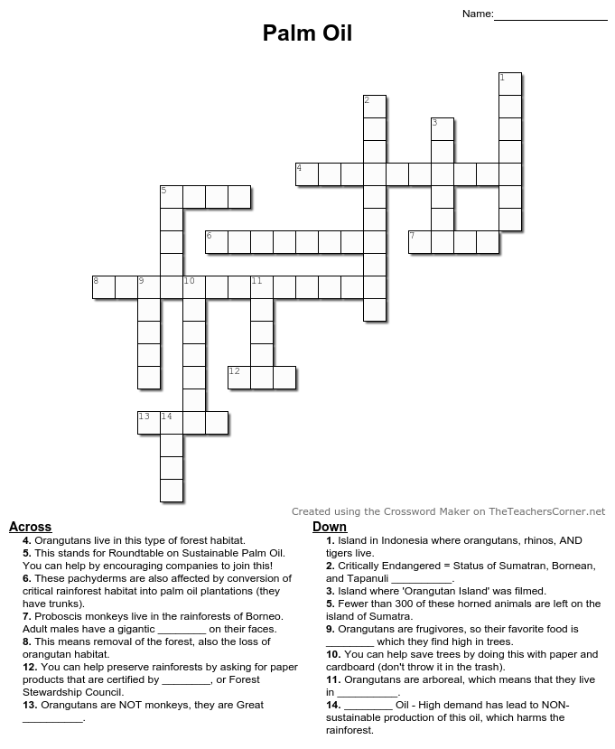

**Make a Difference for Wild Orangutans!**

U

S

O

M

B

R

A

O

A

S

E

R

T

O

F

N

I

A

R

R

N

G

O

P

S

R

H

A

E

U

T

I

E

S

N

O

N

A

H

P

E

L

E

O

I

T

A

T

S

R

E

F

E

D

O

N

A

E

R

R

S

N

C

U

E

Y

I

E

C

T

C

F

S

L

S

P

A

E

L

A

M

**Learn More!**

**cmzoo.org/palmoil**